**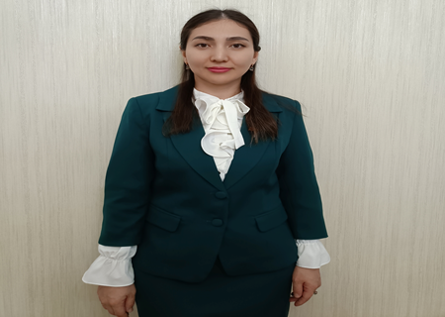**

**900913401660**

**ТАСТАНБЕКОВА Бактыгул,**

**М.Мәметова атындағы №33 жалпы білім беретін мектебінің**

**ағылшын тілі пәні мұғалімі.**

**Түркістан облысы, Жетісай ауданы**

**TECHNOLOGY**

|  |  |
| --- | --- |
| **Learning objectives(s) that this lesson is contributing to** | 4.1.2.1 understand an increasing range of supported questions which ask for personal information;  4.2.3.1 give short, basic description of people and objects, begin to describe past experiences on an increasing range of general and some curricular topics;  4.4.4.1 write with support a sequence of short sentences in a paragraph to give basic personal information;  4.5.3.1 use adjectives, including possessive adjectives, on a growing range of general and some curricular topics to describe things, use simple one-syllable and some two- syllable adjectives [comparative and superlative] to make  comparisons;  4.5.11.1 use has got/have got there is/are statement, negative, question forms including short and full answers and contractions |
| **Lesson objectives** | **Learners will be able to:**  revise jobs; to talk and write about their favourite community helper; tell which of the jobs in the text they need to; act out the dialogue |

**Lesson plan**

|  |  |  |  |  |
| --- | --- | --- | --- | --- |
| **Planned timings** | **Teacher's actions** | **Pupils` actions** | **Assessment** | **Resources** |
| **5 minutes**  **5 minutes** | **ORGANISATION MOMENT:**  Teacher greeting: Good morning,  Good morning.  Good morning to you!  Good morning ,  Good morning.  I’m glad to see you!  Check up hometask: Check the hometask an **“Ice Cream**” method.  Dividing into 2 groups:  1 group Transportation  2 group Professions | Students respond to greeting and take their places  Students match with definitions of professions |  |  |
| **30 minutes** | **MAIN PART**  Teacher show the famous granland’s picture then ask what lesson’s theme.  **TECHNOLOGY**  **Task 2.Listening the text “Baiterek” watch a video.**  **C:\Users\нур\Downloads\baiterec2.jpg**  **C:\Users\нур\Desktop\көрнекілік тапсырма\IMG_20211221_055352.jpg**  **Task 3. Ex:29 Read and choose**  **C:\Users\нур\Desktop\көрнекілік тапсырма\IMG_20211221_055429.jpg**  **Answer key:**   1. **Shorter** 2. **1.037** 3. **Egg** 4. **Fast**   **Relaxing time**    **Task 4. Game: Sounds of transport**    **Task 5. Ex: 16. Read the sentences and match the with the pictures.**  **C:\Users\нур\Desktop\көрнекілік тапсырма\IMG_20211222_020848.jpg**  **Reflection moment**    **Home task:  Ex: 2,3 on page 63 P.B** | The students say what famous pictures then order the letters and find new lesson’s theme.  The pupils listen and follow the text in their books. Then they answer the questions.  pupils some time to read the sentences and choose the correct words. | Formative assessment  Teacher assess the learners work orally | **Track 47 CD1)** |
| **5 minutes** | **ENDING THE LESSON:**  Well what did we do in our lesson?  -Evaluation of the lesson  Give the home task  Sing a Good bye song |  | Feedback | https://www.youtube. com/watch?v=Xcws7UWWDEs |